**BEE 546 CMOS II**

**LAB REPORT: 2**

**GROUP 4:**

Saily Sengupta

Sri Vaishnavi

Tam Nguyen

1. **Goals:**

The goals encompassed carrying out lithography procedures for MASK-2 and MASK-3 patterning. In summary, the process initiates with a predeposition of p-well, followed by the removal of boron glass. Subsequently, we proceed with a drive-in procedure for the p-well and the patterning of the second mask. Advancing in the process, BOE etching is executed, continuing with the removal of boron glass, and conducting field oxidation, concluding with the patterning of MASK #3.

The tasks included:

**Lab-4:**

* P-well predeposition
* Boron glass removal
* P-well resistivity measurement
* RCA Cleaning

**Lab-5:**

* P- well drive-in
* To develop and pattern mask-2 using photolithography (PMOS P+ source/ drain)

**Lab-6:**

* BOE Etching
* P+ Source/ Drain predeposition (PMOS)
* Boron Glass Removal
* Field Oxidation

**Lab-7:**

* Photolithography: Mask 3 patterning

**Briefly, state the objective of the first lithography process (MASK #2 and MASK #3) in your own words.**

The primary objective of the first lithography process for MASK-2 and MASK-3 is to facilitate the precise fabrication of specific components within the semiconductor device. Specifically, MASK-2 is intended for defining the p+ source/drain regions for PMOS transistors, while MASK-3 is designed for defining the N+ source/drain regions for NMOS transistors. This carefully orchestrated lithography process ensures the accurate delineation and deposition of essential features, contributing to the successful realization of PMOS and NMOS components.

1. **Process Overview:**
   1. **Describe fabrication process in detail after Report #1 (Explain the experimental procedure, step by step, in your own words with drawings showing cross-sectional views)**

P-well Predeposition:

Following the development and patterning of MASK#1, the process proceeds with a p-well predeposition. The chosen material is Boron GS 126, exhibiting characteristics closely resembling those of ceramic. Boron and Silicon wafers are arranged alternately on the wafer holder and subjected to deposition at 890°C in a closed furnace tube, for a duration of 15 minutes with a nitrogen gas flow rate of 2000 standard cubic centimeters per minute (sscm). The deposition of boron on the silicon wafer transforms it into a p-type wafer, assuming a glass-like structure termed boron silicon glass (BSG).

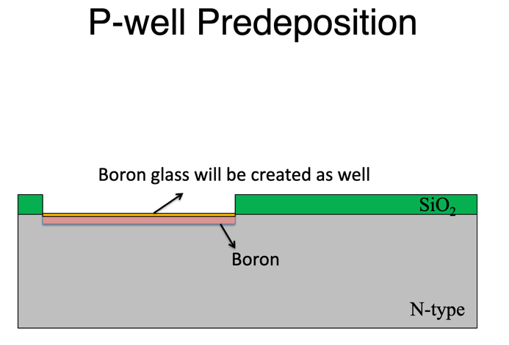 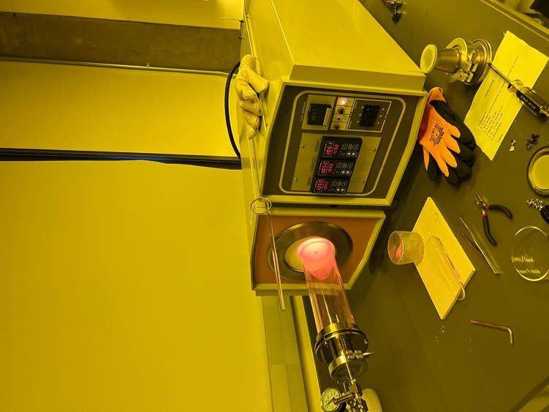

Tube furnace

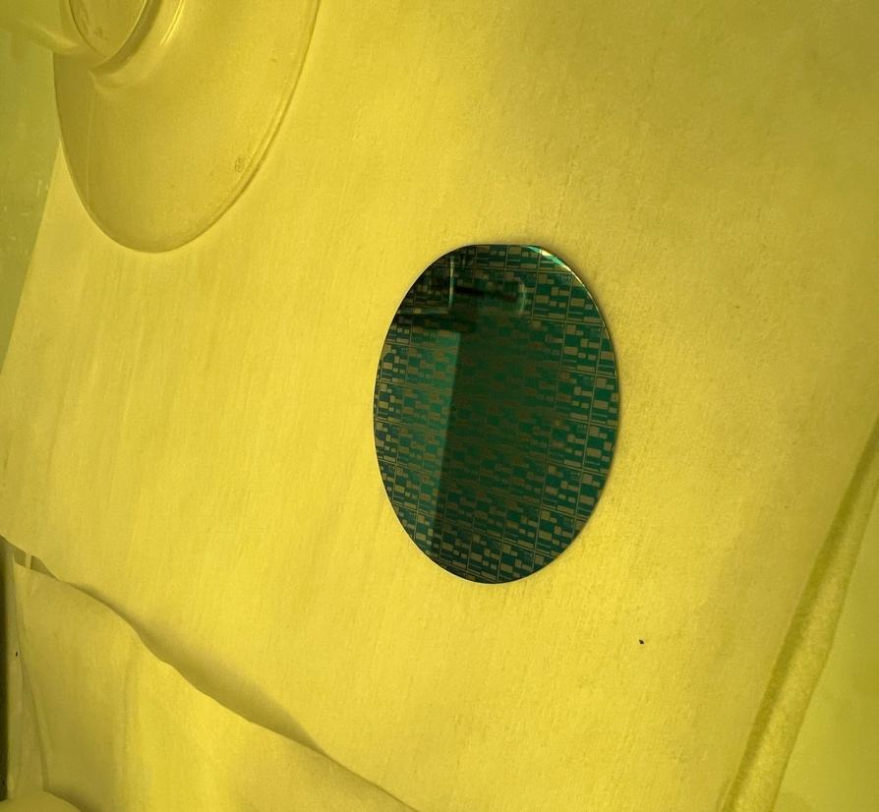 

Wafer after Predep After Predep

BSG Removal:

To remove BSG, the initial step involves rinsing the wafer in a solution of HF: DI in a 1:50 ratio for 2 minutes, followed by a DI rinse for 1 minute. It's noteworthy that the removal of boron oxide is more effective than that of boron silicon.

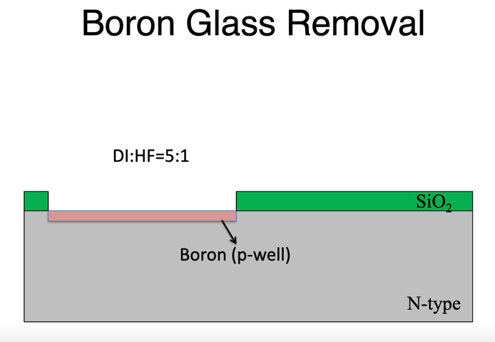 

Wafer after BSG Removal

Chemical Oxidation:

The next step involves chemical oxidation to oxide the boron layer. This is achieved by immersing the wafers in a solution of sulfuric acid and nitric acid (H2SO4:HNO3) in a 1:1 ratio for 5 minutes, followed by a DI rinse for 1 minute. The BN source facilitates the transfer of boron to the wafer through B2O3. The reaction of B2O3 with silicon results in the formation of a heavily doped SiO2 layer, known as borosilicate glass, with a B:Si alloy layer at the BSG:Si interface. While BSG is easily removed with 50:1 DI: HF, the B:Si layer must undergo chemical oxidation before being treated with 50:1 DI: HF. This oxidation process lasts for 20 seconds and is followed by a 1-minute rinse with DI water.

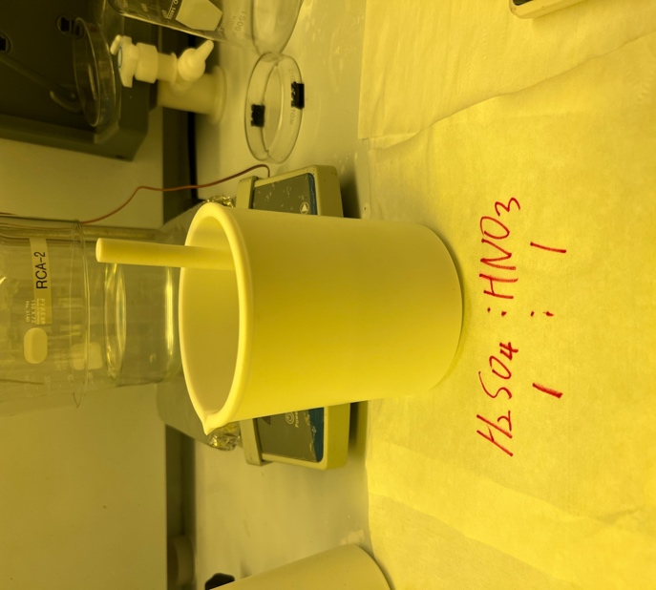 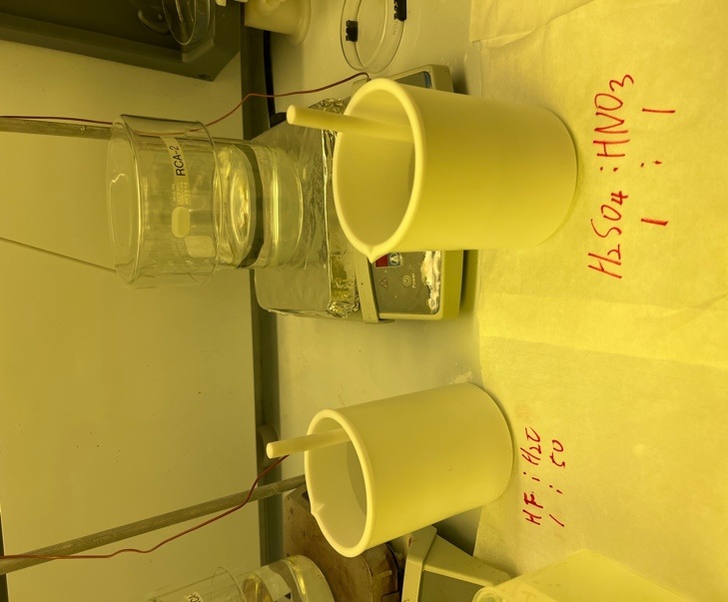

Chemical oxidation Remove chemically oxidized layer

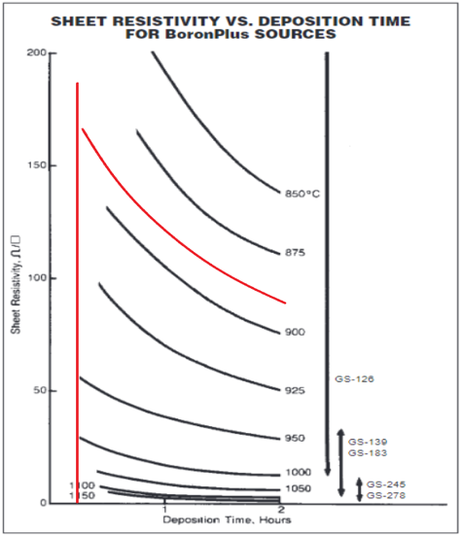The graph illustrates the relationship between sheet resistivity and deposition time for Boron Plus sources. The deposition, conducted at approximately 890°C for 15 minutes, theoretically yielded a sheet resistivity of around 35 ohms. However, after a 4-point probe measurement to determine resistance, the mean value was found to be 37.05 ohms. To confirm the wafer type, a hot probe measurement was performed, indicating a p-type wafer based on an observed current of approximately -20uA.

Sheet resistivity vs time (red curve is predicted for 890C)

RCA Cleaning:

Following these steps, an RCA cleaning was initiated. In the initial phase, the wafer underwent immersion in a solution of DI: H2O2: NH4OH at a 5:1:1 ratio at 80°C for 15 minutes, followed by a DI water rinse for 1 minute. Subsequently, the wafer was immersed in an HF: DI solution at 1:50 ratio for 15 seconds, followed by a final DI water rinse for 30 seconds. The second phase of the RCA cleaning involved a similar process where the wafer underwent immersion in a solution of DI: H2O2: HCl at 80°C for 15 minutes, followed by a DI water rinse for 10 minutes. The wafers were then dried using nitrogen and carefully stored in a vacuum oven for subsequent processing.

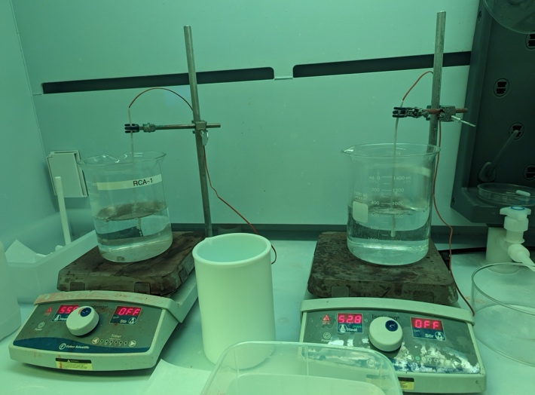

RCA Cleaning

P-well drive-in:

After removing BSG, the process continued with a p-well drive-in at 1050°C with N2 flow at 2000sccm for 1 hour, constituting the first drive-in step. This step continued with alternating dry and wet oxidation processes. Dry oxidation used dry O2 a 2000sccm for 10 minutes, followed by wet oxidation with wet O2 at 2000sccm for 30 minutes, and concluding with dry O2 at 2000sccm for 10 minutes. The resulting oxide thickness was approximately 300nm, and the overall wafer thickness was around 560nm.

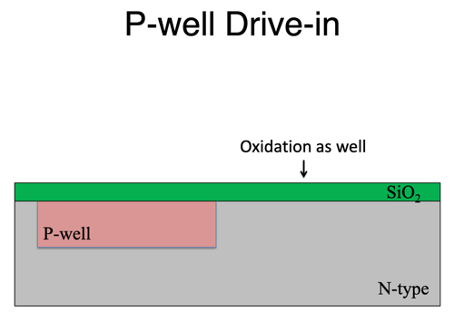 

Wafer after P-well drive-in

HDMS Coating:

In the subsequent stage of the fabrication process, 6 drops of hexamethyldisilane (HMDS) are introduced to enhance the adhesion of the photoresist layer. The deposition of HMDS is accomplished through the spin coating technique, a critical step in ensuring uniformity. The process involves setting the spin speed to 3500 rpm with a dwell time of 10 seconds. During the spin coating, the wafer is subjected to rotation for 30 seconds.

S1813 Photoresist:

A positive photoresist, S1813, was uniformly deposited on a substrate using spin coating. The spin coating process involved applying the photoresist solution to the substrate, followed by spinning at a speed of 3500 revolutions per minute (rpm) for 30 seconds.

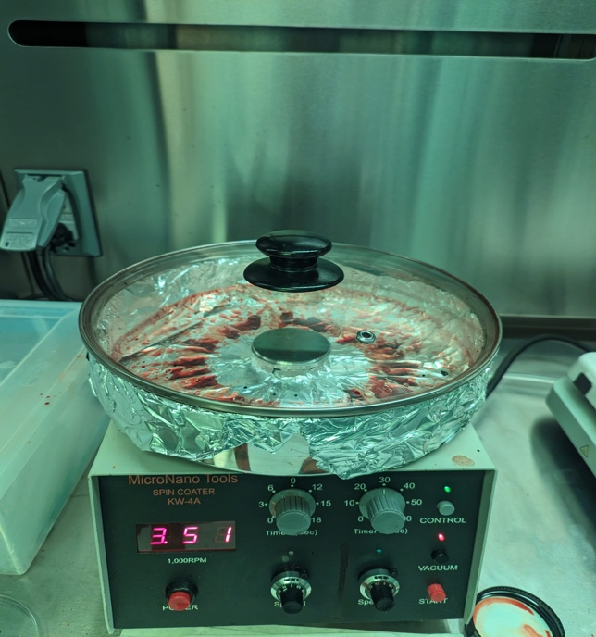 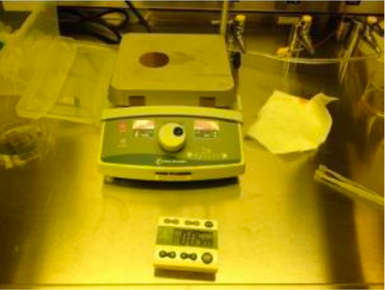

Spin coat Photoresist Soft Baking

Softbake (hotplate):

At a temperature of 120°C, the wafer underwent a soft baking process lasting for 5 minutes. During this soft bake step, the wafer was subjected to controlled heating, allowing for the removal of residual organic solvents from the photoresist layer, enhancing adhesion, and preparing the photoresist for subsequent processing steps in semiconductor fabrication.

UV exposure (#2 Mask):

The wafer underwent patterning through the UV exposure technique, utilizing a UV lamp with a power of 21.47 mW/cm2. The exposure energy for this process was set at 60 millijoules per square centimeter. The exposure time required to achieve this energy level was 7 secs.

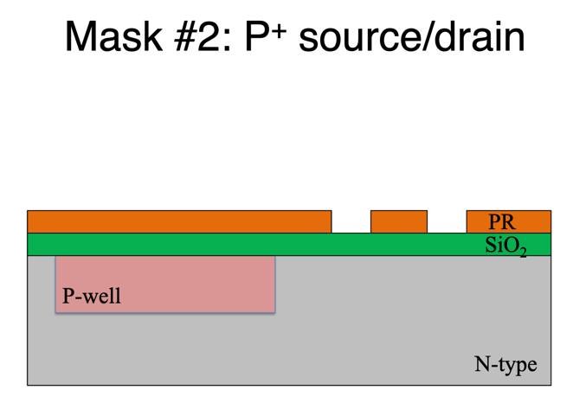 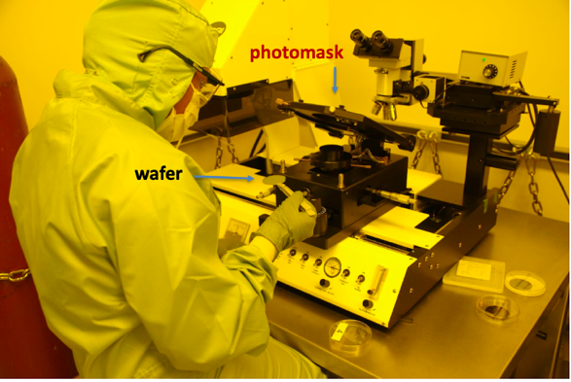

Photomask aligning

 

Mask -2 developed Mask -2 developed

PR Developing:

To develop the photoresist layer, the mask is immersed in MF 319: undiluted solution for 40 seconds, followed by a thorough washing with DI water for 1 minute and dried using nitrogen for 1 min. If, upon inspection, the photoresist is found to be underdeveloped, it is recommended to repeat the PR development process.

Hardbake (hotplate):

The wafer is hard baked for 10 minutes to enhance the development of the photoresist pattern on the substrate. During the hot bake, the temperature is increased to 120°C, which helps in achieving uniformity in the photoresist layer and promotes the cross-linking or hardening of the exposed areas.

Sio2 Etching:

The silicon dioxide (SiO2) etching process commences with the application of buffered oxide etching (BOE) in a 6:1 ratio for a duration of 9 minutes and 30 seconds, specifically tailored for SiO2 layer with a thickness below 600 nanometers (nm). Following the etching step, the wafer undergoes a thorough rinsing procedure using deionized water, lasting for one minute, ensuring the removal of any residual etchant solution. Subsequent to rinsing, the wafer is subjected to microscopic inspection to detect the presence of any remaining oxide. If oxide residuals are identified during inspection, further etching is conducted in increments of 30 seconds until complete removal of the oxide layer is achieved. This meticulous approach to SiO2 etching ensures precise control over the process and guarantees the thorough removal of unwanted oxide residues, meeting the stringent quality standards required for semiconductor fabrication.

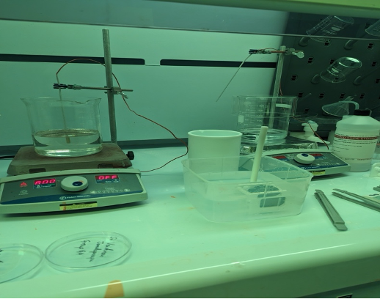 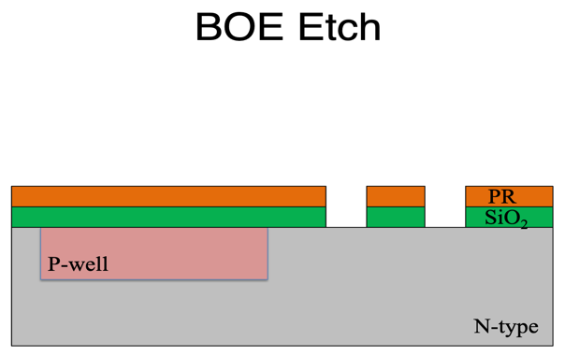

BOE Etching

 

PR Removal:

Following etching, the photoresist layer is eliminated using a 1165 etchant solution for 5 mins at 80°C, after which the wafer undergoes thorough rinsing with deionized (DI) water for 1 minute. A microscopic inspection is then conducted to detect any remaining photoresist residue. If such residue is observed, a degreasing step is deemed necessary. It is crucial to note that incomplete removal of the photoresist layer is identified as the most prevalent cause of contamination in furnace tubes during subsequent processing steps. This comprehensive process ensures the effective removal of photoresist materials, contributing to the overall cleanliness and reliability of the semiconductor fabrication process.

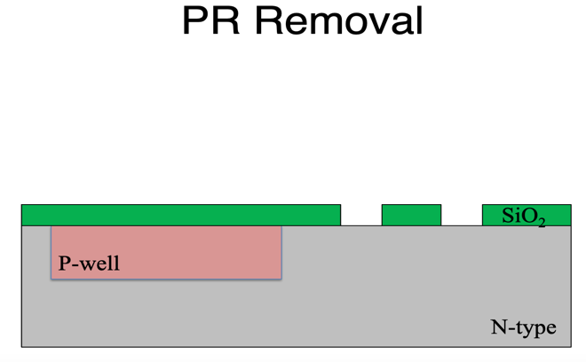

RCA Cleaning:

The process continues with the RCA cleaning of the wafer. The first step of RCA cleaning process is to immerse the wafer in a solution of *DI: H2O2: NH4OH* in 5:1:1 ratio at 80°C for 15 minutes. The next step is to rinse the wafer in DI water for 1 minute. Following this, the wafer is dipped in a solution of HF: DI in 1:50 ratio for 30 seconds. The second part of RCA cleaning process is to immerse the wafer in a solution of *DI: H2O2: HCl* in 5:1:1 ratio at 80°C for 15 minutes. The last step is to rinse the wafer with DI water for 10 minutes. To finish the RCA cleaning process, the wafer is dried using nitrogen and stored in the vacuum oven.

P+ Source/ Drain predeposition (PMOS):

The predeposition process for creating p+ source/drain regions in PMOS transistors involves precise parameters to achieve the desired target boron concentration. With a target boron gas source (GS) set at 126, the process is conducted at a temperature of 935 degrees Celsius, ensuring optimal conditions for dopant activation. Nitrogen gas is utilized as the carrier gas, with a flow rate of 1000 standard cubic centimeters per minute (sccm), facilitating uniform distribution of the boron dopant. The duration of the predeposition process is set at 30 minutes, allowing sufficient time for the boron atoms to diffuse into the semiconductor substrate and establish the desired concentration profile for the p+ source/drain regions.

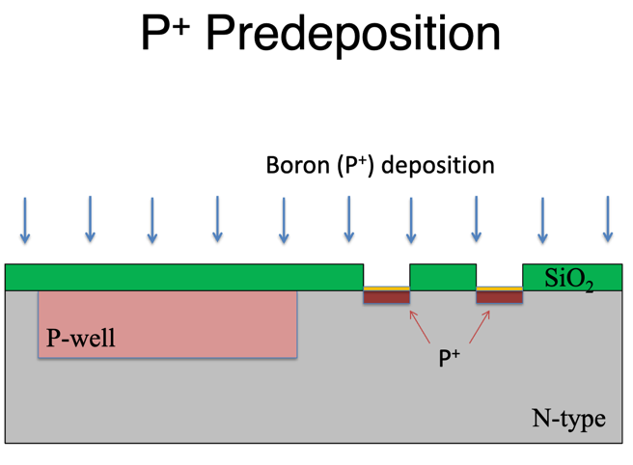 

After Boron deposition

Boron Glass Removal:

The process of removing boron glass entails a meticulously orchestrated series of steps to ensure effective elimination of the material while maintaining the integrity of the semiconductor substrate. Beginning with a solution of hydrofluoric acid (HF) diluted in deionized water (DI) at a ratio of 1:50, the boron glass is subjected to this etchant mixture for 2 minutes. Following this step, the wafer undergoes a thorough rinse with deionized water for 1 minute to remove any residual HF solution. Subsequently, a solution comprising sulfuric acid (H2SO4) and nitric acid (HNO3) in a 1:1 ratio is employed for further removal of boron glass, with the wafer immersed in this mixture for a period of 10 minutes. A subsequent rinse with deionized water for 1 minute is conducted to cleanse the wafer surface. Finally, the boron glass removal process concludes with another brief immersion in HF diluted in DI at a ratio of 1:50 for 1 minute, followed by a thorough rinse with deionized water lasting for 10 minutes. This comprehensive sequence of steps ensures the complete removal of boron glass while maintaining the purity and integrity of the semiconductor substrate, facilitating subsequent processing steps in semiconductor device fabrication.

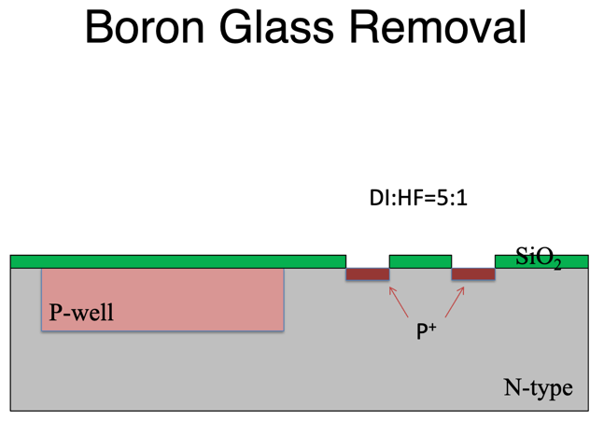 

After Boron glass removal

Field Oxidation:

The field oxidation process, critical for creating insulating layers within semiconductor devices, involves a carefully controlled sequence of steps to achieve precise results. Beginning at a temperature of 1050 degrees Celsius, the semiconductor wafer is exposed to a flow of oxygen gas at a rate of 1000 standard cubic centimeters per minute (sccm) for dry oxidation, lasting for a duration of 10 minutes. This initial step promotes the formation of a thin layer of oxide on the wafer surface. Subsequently, the process transitions to wet oxidation, where the wafer remains at the same temperature for a prolonged period of 2 hours. This extended wet oxidation step facilitates the growth of a thicker oxide layer, essential for insulating various components within the semiconductor device. Following the wet oxidation phase, the process reverts to dry oxidation for a final duration of 10 minutes, further enhancing the oxide layer's thickness and uniformity.

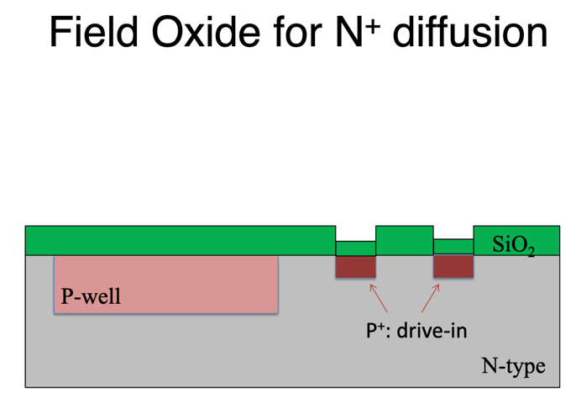

HDMS Coating:

In the subsequent stage of the fabrication process, 6 drops of hexamethyldisilane (HMDS) are introduced to enhance the adhesion of the photoresist layer and converting the wafer from hydrophilic to hydrophobic. The deposition of HMDS is accomplished through the spin coating technique, a critical step in ensuring uniformity. The process involves setting the spin speed to 3500 rpm with a dwell time of 10 seconds. During the spin coating, the wafer is subjected to rotation for 30 seconds.

S1813 Photoresist:

A positive photoresist, S1813, was uniformly deposited on a substrate using spin coating. The spin coating process involved applying the photoresist solution to the substrate, followed by spinning at a speed of 3500 revolutions per minute (rpm) for 30 seconds.

Softbake(hotplate):

At a temperature of 120°C, the wafer underwent a soft baking process lasting for 5 minutes. During this soft bake step, the wafer was subjected to controlled heating, allowing for the removal of residual organic solvents from the photoresist layer, enhancing adhesion, and preparing the photoresist for subsequent processing steps in semiconductor fabrication.

UV exposure (#3 Mask):

The wafer underwent patterning through the UV exposure technique, utilizing a UV lamp with a specified power level. The exposure energy for this process was set at 60 millijoules per square centimeter. The exposure time required to achieve this energy level was 7 secs. The resulting blue patterns observed on the wafer are attributed to the features defined by Photomask 3, indicating the successful transfer of the desired pattern onto the wafer surface during the UV exposure process.

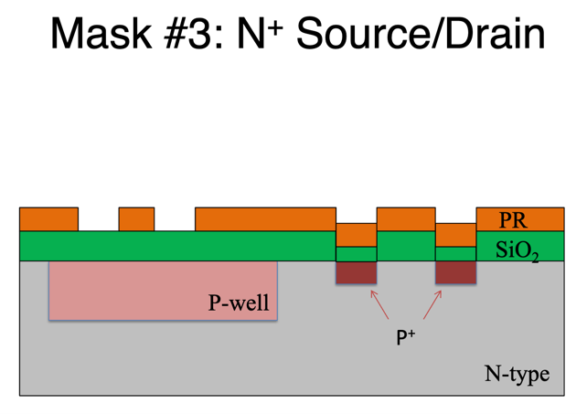 

Mask 3 developed

PR Developing:

To develop the photoresist layer, the mask is immersed in MF 319: undiluted solution for 40 seconds, followed by a thorough washing with DI water for 1 minute and dried using nitrogen for 1 min. If, upon inspection, the photoresist is found to be underdeveloped, it is recommended to repeat the PR development process.

Hardbake (hotplate):

The wafer is hard baked for 10 minutes to enhance the development of the photoresist pattern on the substrate. During the hot bake, the temperature is increased to 120°C, which helps in achieving uniformity in the photoresist layer and promotes the cross-linking or hardening of the exposed areas.

Drying the wafer:

The wafer is dried using nitrogen and stored in the vacuum oven.

* 1. **Identify experiment equipment and tools used for fabrication process (**List the names of test equipment, instruments, tools, materials, etc.**)**

1. **DI Water Bath-** torinse the wafer after each chemical treatment.
2. **Wafer Holder or Cassette-** to hold and handle the semiconductor wafers during the RCA cleaning process.
3. **Tongs or Tweezers-** Non-contaminating tools to handle wafers during the cleaning process
4. **Nitrogen Gun or Compressed Air-** to dry the wafer after rinsing.
5. **Microscope -** to examine the surface of the wafer after etching to detect any defects or inconsistencies and ensure that the desired pattern has been achieved.
6. **Timer or stopwatch -** to accurately control the duration of the processes
7. **Temperature monitoring device-** to maintain the desired temperature range
8. **Buffered oxide etchant (BOE) solution-** to etch silicon dioxide (SiO2)
9. **Etching bath or wet bench setup-** a container to immerse the wafer in BOE for etching.
10. **1165 etchant solution**: to remove PR.
11. **Mask Aligner-** to align the mask with the wafer and expose the photoresist to light for pattern transfer.
12. **Photomask-** A high-resolution mask containing the pattern to be transferred onto the wafer. It is typically made of quartz or glass with a chrome pattern.
13. **Photoresist Spinner-** to Coat the wafer with a thin, uniform layer of photoresist. The spinner rotates the wafer, spreading the photoresist evenly.
14. **UV Light Source-** Provides the ultraviolet (UV) light necessary for exposing the photoresist through the photomask.
15. **Soft Bake Oven-** Performs a controlled, low-temperature baking step to further evaporate solvents from the photoresist.
16. **Mask Holder-** Holds the photomask securely in place during the alignment and exposure steps.
17. **Hard Bake Oven-** Heats the wafer to a higher temperature to cure the photoresist and make it more durable.
18. **Fume Hood or Exhaust System-** to exhaust and remove potentially hazardous fumes generated during the BOE etching process.
19. **HDMS, S1813**- to spin coat the wafer for patterning.
20. **DI: H2O2:NH4OH, HF: DI, DI: H2O2: HCl** – for RCA Cleaning
21. **Dopant gas source**: Boron is used to introduce dopant atoms into the semiconductor substrate
22. **Four-Point Probe Setup-** to measure the resistivity of the wafer.

**3. Discussion:(**Present the test results using pictures, graphs and/or tables as much as you can and explain the results)

* 1. **Diffusion Process (Brief introduction of Diffusion and Calculate Sheet resistance Boron** (**P-well Predeposition, Lab 4)**

Diffusion is a fundamental process in semiconductor manufacturing used to introduce dopant atoms into semiconductor materials, altering their electrical properties and enabling the formation of various semiconductor devices. This process involves the controlled movement of dopant atoms through the crystalline lattice of a semiconductor material, typically silicon, to create regions of desired electrical conductivity. The diffusion process can be broadly categorized into two main types:

* **Solid-State Diffusion**: In solid-state diffusion, dopant atoms are introduced into a semiconductor material by thermal annealing in the presence of a dopant source. During annealing, the wafer is heated to high temperatures (typically in the range of 800 to 1200 degrees Celsius) in a controlled atmosphere, allowing dopant atoms from the source material to diffuse into the semiconductor lattice. The dopant atoms diffuse through the lattice by hopping from one lattice site to another, driven by the concentration gradient and thermal energy. Solid-state diffusion is commonly used to form shallow junctions and adjust the doping concentration in semiconductor devices.
* **Dopant Gas Diffusion (Atmospheric Pressure Diffusion)**: Dopant gas diffusion involves introducing dopant atoms into a semiconductor material by exposing the wafer to a gas containing the dopant atoms at elevated temperatures. The dopant atoms diffuse into the semiconductor material by adsorption onto the surface and subsequent incorporation into the lattice during annealing. Dopant gas diffusion is often used in processes such as epitaxy and chemical vapor deposition (CVD) to grow doped semiconductor layers.

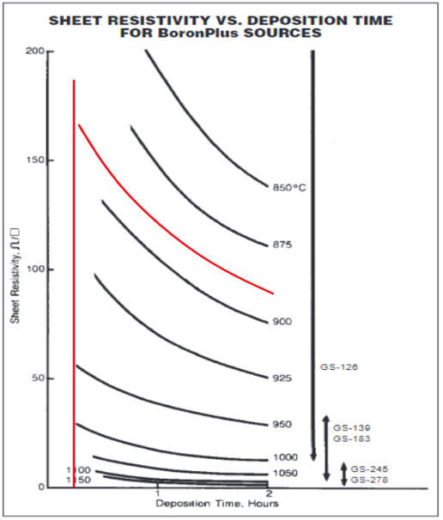**Resistivity measurements using the 4-point probe method**: 35.67Ω

**Sheet resistivity vs time (red curve is predicted for 890oC)**

Sheet resistance was calculated by

$$R_{Sheet} = (R_measured) × (4.532)$$

$$R_{Sheet}=35.67 × 4.532=161.656 /sq$$

When compare to the Boron’s specification sheet, the calculated sheet resistivity (RSheet=161.656Ω/sq) is within reasonable expected range when deposit Boron GS 126 at 890oC for 15 minute (0.25hr)

* 1. **Photolithography process (Brief introduction of photolithography)**

Photolithography is a key process in semiconductor manufacturing used to create intricate patterns on semiconductor wafers, essential for the fabrication of integrated circuits and other microelectronic devices. This highly precise and controlled technique involves transferring a pattern from a photomask or reticle onto a light-sensitive photoresist coating on the surface of a semiconductor wafer. The photolithography process typically consists of several sequential steps:

* **Substrate Preparation**: The semiconductor wafer is thoroughly cleaned and prepared to ensure a clean and uniform surface for the subsequent processing steps.
* **Photoresist Application**: A thin layer of photoresist material is spin-coated onto the surface of the wafer. Photoresist materials can be either positive or negative, depending on whether they become soluble upon exposure to light.
* **Mask Alignment**: A photomask or reticle containing the desired pattern is aligned precisely over the coated wafer using specialized alignment equipment. The mask defines the areas where material will be removed or retained during subsequent processing steps.
* **Exposure**: The coated wafer is exposed to ultraviolet (UV) light through the photomask, which contains transparent regions corresponding to the desired pattern. UV light passes through the mask, exposing the photoresist coating on the wafer in the pattern defined by the mask.
* **Development**: The exposed photoresist is developed using a chemical solution, which selectively removes either the exposed (positive resist) or unexposed (negative resist) regions of the photoresist coating, revealing the patterned areas on the wafer.
* **Etching**: The patterned photoresist layer serves as a mask for subsequent material removal steps, such as etching. The exposed regions of the wafer are etched using specialized etchants, transferring the pattern into the underlying material (e.g., silicon dioxide, silicon).
* **Photoresist Stripping**: Once the desired pattern has been transferred into the underlying material, the remaining photoresist is stripped away using chemical solvents or plasma processes, leaving behind the patterned features on the wafer surface.
  1. **Calculate oxide thickness (Based LAB 6) based on the process parameters and compare it with the measured oxide thickness**

To calculate the oxide thickness based on process parameters, the Deal-Grove model can be used. It is widely used in semiconductor manufacturing for predicting the thickness of oxide layers. Below are Deal-Grove model equations are used to calculate thickness of the oxidation where coefficients A, B and τ can be found in table below.

$$x_{0}^{2}+Ax_{0}=B(t+τ)$$

$$τ=\frac{x_{i}^{2}}{B}+\frac{x_{i}}{B/A}$$

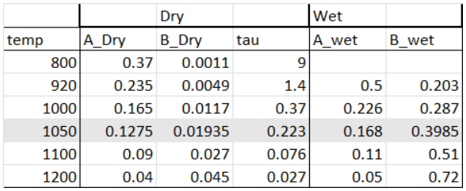

Oxidation coefficients for silicon

Before we start the second field oxidation there is a layer of oxidation from previous field oxidation. The measured oxide thickness was found to be 270 nm, after completing the previous field oxidation fabrication steps.

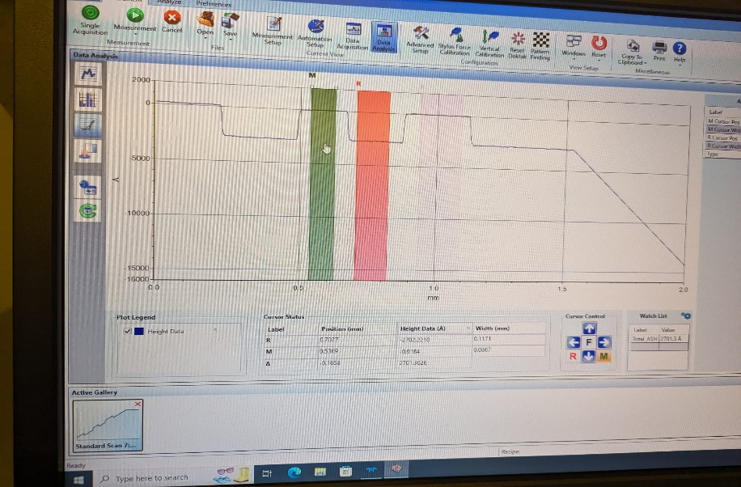

Measured thickness of oxidation from field oxidation #1

In addition, during P-well drive in, the wafer was treated with O2 at 1100oC; therefore the entire wafer is oxidized as well. We need to account for the extra oxidation outside planned field oxidation. The process is as follow:

* Dry oxidation for 10 minutes at 1100oC:
* Wet oxidation for 30 minutes at 1100oC:
* Dry oxidation for 5 minutes at 1100oC:

The actual field oxidation thickness calculation is shown below. However, due to lacking of coefficients at 1050oC, we used a linear extrapolation to estimate coefficients at 1050oC. The process and thickness calculation is as follow:

* Dry oxidation for 10 minutes
$$τ=\frac{{0.550}^{2}}{0.01935}+\frac{0.550}{{0.01935}/{0.1275}}=19.257hr$$

$$x_{0}^{2}+0.1275x_{0}=0.01935\left(0.167+19.257\right) \\ solve for x=0.553μm$$

* Wet oxidation for 2 hours
$$τ=\frac{{0.553}^{2}}{0.3985}+\frac{0.553}{{0.3985}/{0.168}}=1.000hr$$

$$x_{0}^{2}+0.168x_{0}=0.3985\left(2+1\right) \\ solve for x=1.013μm$$

* Dry oxidation for 10 minutes

$$τ=\frac{{1.013}^{2}}{0.01935}+\frac{1.013}{{0.01935}/{0.1275}}=59.707hr$$

$$x_{0}^{2}+0.1275x_{0}=0.01935\left(0.167+59.707\right) \\ solve for x=1.0145013μm=10145.013Å$$

The final result after completed field oxidation is 10143.013 $Å$

Thickness measured 10583.184 $Å$

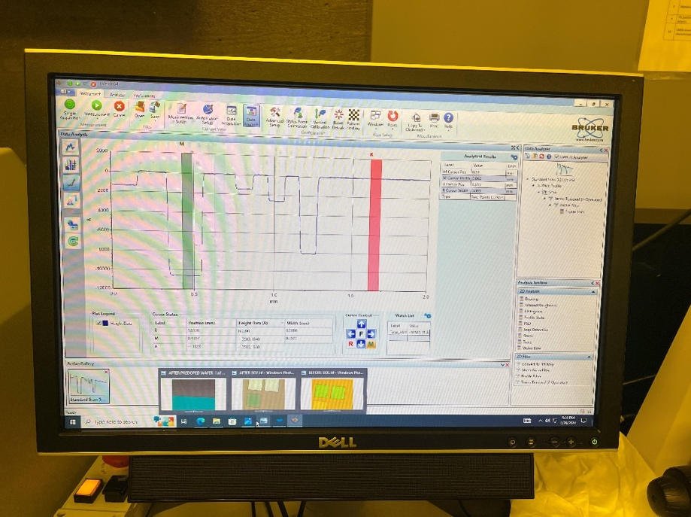

Oxidation thickness after second field oxidation

$$\%Error= \frac{|t_{measured}-t_{calclated}|}{t_{camculated}}×100=\frac{|10583.184-10143.013|}{10143.013}×100=4.34\%$$

There is discrepancy between the calculated thickness and measured thickness. However, the error is 4.34%, it is within acceptance error limits defined by industry standards, process specifications, and customer requirements.

**4. Discussion:**

* 1. **Discuss probable sources of experimental error and how (if possible) they can be eliminated.**

1. **Source of Error:** Poor contact between the measurement probes and the wafer can produce resistance. **Elimination:** Proper probe alignment and contact should be ensured. A small amount of pressure should be applied to ensure good electrical contact.
2. **Source of Error:** Non-uniform coating of HDMS on the wafer surface. **Elimination:** The photoresist should be wiped off and the wafer should be cleaned again and dried with nitrogen vacuum before developing photoresist again. The cleanliness of the wafer surface should be ensured and high-quality HDMS should be used.
3. **Source of Error:** Misalignment between the mask and the wafer during exposure. **Elimination:** Precise alignment procedures should be implemented, and the mask aligner should be regularly calibrated.
4. **Source of Error:** Underdeveloped PR. **Elimination:** If the Photoresist is underdeveloped, PR should be developed again following the lithography process.
5. **Source of Error:** Residual oxide after etching. **Elimination:** If oxide is found after BOE etching, the wafer should be etched again in 30 secs interval until the oxide is removed.
6. **Source of Error:** Incomplete removal of photoresist leading to residual PR. **Elimination:** Thorough inspection through optical microscopes should be done to detect any remaining photoresist. If found, degreasing is necessary.
7. **Source of Error:** Incomplete removal of the BOE solution or other stripping chemicals after rinsing. **Elimination:** Thorough rinsing steps using deionized water should be implemented.
8. **Source of Error**: Inconsistent concentrations of the etching solutions or the oxidizing solution during the oxidation process may result in non-uniform etching rates and oxide growth rates and thicknesses across the wafer surface. This variability can occur due to improper solution preparation or degradation of chemicals over time. **Elimination:** Ensuring proper solution agitation using stirring mechanisms or rotating the wafer during the oxidation process can help promote uniform mixing of the solution and enhance oxide growth rates.
9. **Source of Error**: Inhomogeneous deposition across the wafer surface can result in variations in the thickness and doping level of the P-well layer, affecting device performance. **Elimination:** Optimizing deposition parameters, such as gas flow rates, deposition time, and substrate temperature, to achieve uniform deposition across the wafer surface can help minimize variations. Additionally, using deposition techniques that provide good wafer-to-wafer and within-wafer uniformity, such as chemical vapor deposition (CVD) or plasma-enhanced chemical vapor deposition (PECVD), can help improve deposition uniformity.
10. **Discuss if any of the processes can be further improved for this course.**

The current processes are well-established and efficient. Continuous monitoring and optimization have already been implemented, and it can be said that the existing materials meet industry standards and procedures deliver high-quality outputs. Thus, at this point, further improvements may not be necessary.

**5. References:**

* Textbook- Stephen A. Campbell, “***Fabrication Engineering at the Micro- and Nanoscale***,” 4th edition, Oxford University Press, 2013
* CMOS 1 and CMOS 2 lecture notes/ slides
* https://en.wikipedia.org/wiki/RCA_clean
* https://www.pveducation.org/pvcdrom/characterisation/four-point-probe-resistivity-measurements
* https://inside.mines.edu/~sagarwal/phgn435/BOE.html
* https://fabweb.ece.illinois.edu/recipe/pr4remove.aspx
* https://www.platypustech.com/an-overview-of-the-photolithography-process
* https://en.wikipedia.org/wiki/Hot-point_probe